**Friends**

______________________________________________________________________________

Name: Maud Forsberg-Davis

School: Morris Early Learning Center

District: Milford Grade Level: K

Implemented by: School Counselor

**STANDARDS**

Standard 1: Students will acquire the attitudes, knowledge, and skills that contribute to

effective learning in school and across the lifespan.

Standard 2: Students will complete school with the academic preparation essential to choose

from a wide variety of substantial postsecondary options, including college.

Standard 3: Students will understand the relationship of academics to the world of work, to life

at home and in the community.

**MATERIALS**

* Rainbow Fish and the Big Blue Whale
* Worksheet
* Pencils
* Crayons
* Scissors
* Glitter Glue

**ACTIVITY**

* Student come in and sit on the floor in front of the smartboard
* Read the book
  + ASK
    - If you were Rainbow Fish, how would you feel about meeting the Big Blue Whale?
    - Why were Rainbow Fish and the other fish afraid of the whale
    - What kind of things could Rainbow Fish and whale do now when they are friends/
    - If Rainbow Fish had never talked to the whale, what do you think could have happened?
    - Discuss and list words that describe friendship (write them on the board)
* Seat the students at the tables and hand out the worksheets
* Ask the students to write down one word that they think describes a FRIEND.
* Color the fish and cut it out, collect it and explains that we are creating a “SCHOOL OF FRIENDS” outside this classroom.

**ESTIMATED TIME:** 30 Minutes

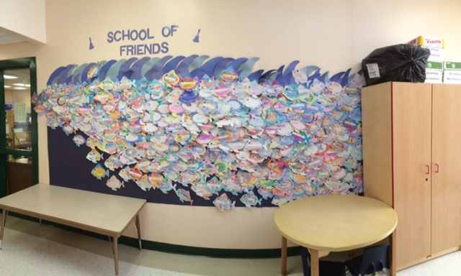



patient

kind, loyal

friendly, loving compassionate

caring, special,

pleasant



helpful

sensitive

generous

giving

listening

supporting

understanding

C:\Users\Tony & Maud\AppData\Local\Microsoft\Windows\Temporary Internet Files\Content.IE5\3LOQU82V\MC900197836[1].wmf

**thoughtful**

**careful, forgiving**

**courteous**

**dedicated, responsible**

**forgiving, truthful, hugging**

Words that Describe a Good Friendship

Have you ever thought of what friendship really means? It is really hard to put into words. Friendships are [mutually](http://www.yourdictionary.com/mutual) beneficial, meaning each of you get something out of the relationship. Friends are there when you need them, whether to comfort, support, congratulate, or just listen.

Here is a list of words that describe a good friendship: affable, affectionate, amiable, [amicable](http://www.yourdictionary.com/amicable), attentive, available, believable, brave, caring, cheerful, considerate, cordial, discerning, easygoing, empathetic, faithful, forgiving, funny, generous, gentle, giving, good listener, heartfelt, honest, humorous, kind, loving, loyal, nice, optimistic, punctual, reliable, responsible, sensitive, sincere, sociable, sweet, sympathetic, tactful, thoughtful, trustworthy, truthful, warm, warm-hearted, winning, and wonderful.

## Sayings about Friends

## If you are composing a speech or writing a paper and need some sayings or quotes about friendship, here are a few for you to consider:

* Relationships are all there is. Everything in the universe only exists because it is in relationship to everything else. Nothing exists in isolation. We have to stop pretending we are individuals that can go it alone. - Margaret J. Wheatley
* The more I think it over, the more I feel that there is nothing more truly artistic than to love people. - Vincent van Gogh
* Let us be grateful to people who make us happy; they are the charming gardeners who make our souls blossom. - Marcel Proust
* The most beautiful discovery true friends make is that they can grow separately without growing apart. - Elizabeth Foley
* Friendship is a sheltering tree. - Samuel Coleridge
* It is one of the blessings of old friends that you can afford to be stupid with them. - Ralph Waldo Emerson
* The most basic and powerful way to connect to another person is to listen. Just listen. Perhaps the most important thing we ever give each other is our attention.... A loving silence often has far more power to heal and to connect than the most well-intentioned words. - Rachel Naomi Remen
* Good friends, good books and a sleepy conscience: this is the ideal life. - Mark Twain
* Consult your friend on all things, especially on those which respect yourself. His counsel may then be useful where your own self-love might impair your judgment. - Seneca
* The only way to have a friend is to be one. - Ralph Waldo Emerson  <http://www.yourdictionary.com/grammar/style-and-usage/words-that-describe-a-good-friendship.html>