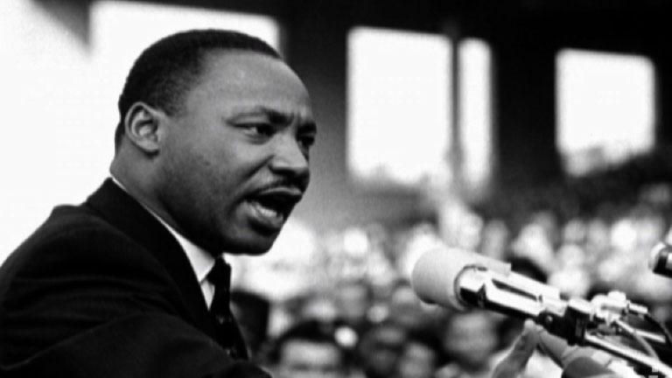
Dr. Martin Luther King, Jr. had a dream. I have a dream too… This is my dream.

__I have a dream that___________________________________
_______________________________________________________________________________________________________________________________________________________________________________________________________________________________________________________________________

This is me….
Dr. Martin Luther King, Jr.

